Four Major Conventions of Greek Pronunciation
Greek Letters | Erasmian Pronunciation | Historic Attic Pronunciation | Historic Biblical Pronunciation | Modern Pronunciation
 | a: father | same | same | same
 | b: boy | b: mob | v but only using the lips | v
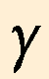 | g: got¹ | same | y: year or  g in a gurgle sound | same
 | d | same | th: this | same
 | e: get | same | same | same
 | dz | same | same | same
 | a: late | same | i: ski | same
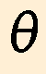 | th | t-h: tarnation | th: moth | same
 | i: pit (if short)  i: ski (if long) | i: ski (always) | same | same
 | k: kite | k: pick | same | same
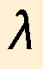 | l | same | same | same
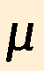 | m | same | same | same
 | n | same | same | same
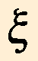 | x | same | same | same
 | o: obey | quicker than o in or | same | same
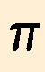 | p: pick | p: skip (less aspiration) | same | same
 | r | Scottish r | French or German r | same
 | s | same | same | same
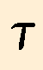 | t | same | same | same
 | French u | same | same | i as in ski
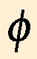 | ph as in phone | p-h as in tip-him | ph as in phone | same
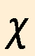 | German ch | k-h | German ch (which differs with following vowels) | same
 | ps | same | same | same
 | o: note | aw: saw | o: or | same
Diphthongs
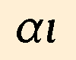 | ai as in aisle | same | e as in pet or ai as in air | same
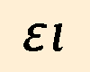 | a as in fate | same | ei as in receive | same
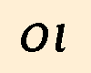 | oi as in oil | same | i as in ski | same
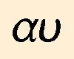 | ow in cow | same | av as in Ave Maria² | same
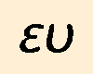 | eu in feud | same | ev as in ever³ | same
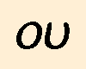 | like ou in soup | same | same | same
¹ When gamma precedes kappa, chi, or another gamma it has a nasal sound like ng.
² When this diphthong precedes an aspirated letter like t it will sound af instead of av.
³ When this diphthong precedes an aspirated letter like t it will sound ef instead of ev.

